**Transactions Functions Tables:**

**User Story 1:**

1. **As a non-registered user, I want to view the product details.**

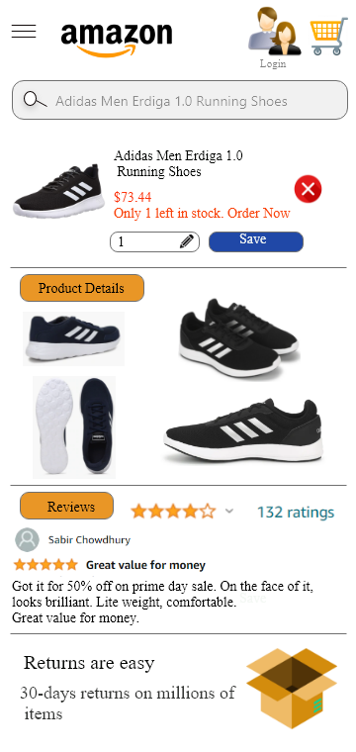

|  |  |  |  |  |  |
| --- | --- | --- | --- | --- | --- |
| **Transaction Fuctions/Screen** | **Type** | **DET** | **RET** | **FTR** | **Weightage** |
| **View Product** | **EI** | **6** | **NA** | **2** | **Low** |

**User Story 2:**

1. **As a customer user, I want to filter products so that I can find the items based on different categories.**

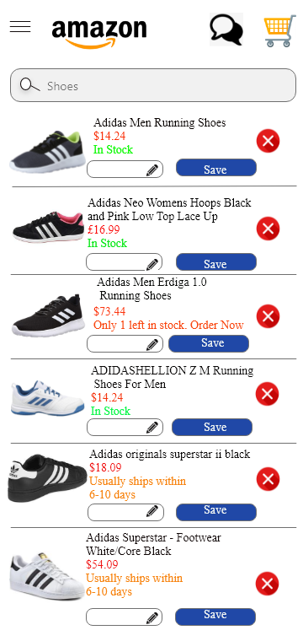

|  |  |  |  |  |  |
| --- | --- | --- | --- | --- | --- |
| **Transaction Fuctions/Screen** | **Type** | **DET** | **RET** | **FTR** | **Weightage** |
| **Filter Product** | **EO** | **5** | **NA** | **3** | **Low** |
| **Delete Product** | **EI** | **2** | **NA** | **1** | **Low** |

**User Story 3:**

1. **As a registered user, I want to buy a product from the website.**

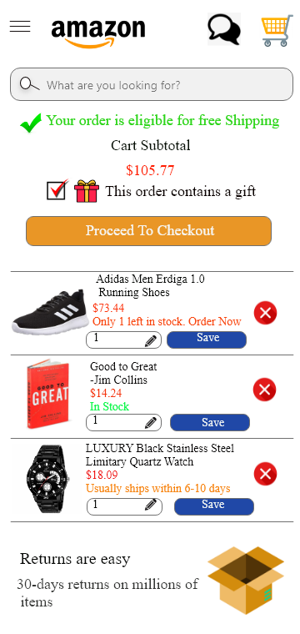

|  |  |  |  |  |  |
| --- | --- | --- | --- | --- | --- |
| **Transaction Fuctions/Screen** | **Type** | **DET** | **RET** | **FTR** | **Weightage** |
| **Buy Product** | **EQ** | **3** | **NA** | **2** | **Low** |

**User Story 4:**

1. **As a registered user, I want to add money to my AmazonPay account so that I can pay directly from it rather than using a bank account.**

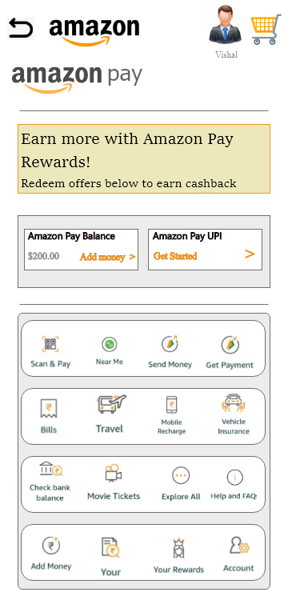

|  |  |  |  |  |  |
| --- | --- | --- | --- | --- | --- |
| **Transaction Fuctions/Screen** | **Type** | **DET** | **RET** | **FTR** | **Weightage** |
| **Add Money** | **EI** | **9** | **NA** | **2** | **Average** |

**User Story 5:**

1. **As a customer, I want to add my location/address of delivery through map by pinning the location.**

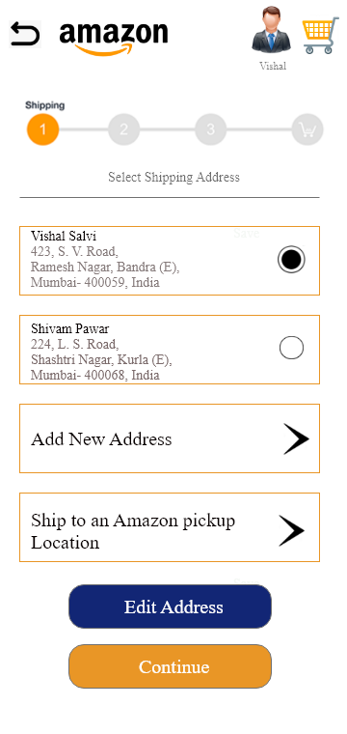

|  |  |  |  |  |  |
| --- | --- | --- | --- | --- | --- |
| **Transaction Fuctions/Screen** | **Type** | **DET** | **RET** | **FTR** | **Weightage** |
| **Add Address** | **EO** | **3** | **NA** | **2** | **Low** |